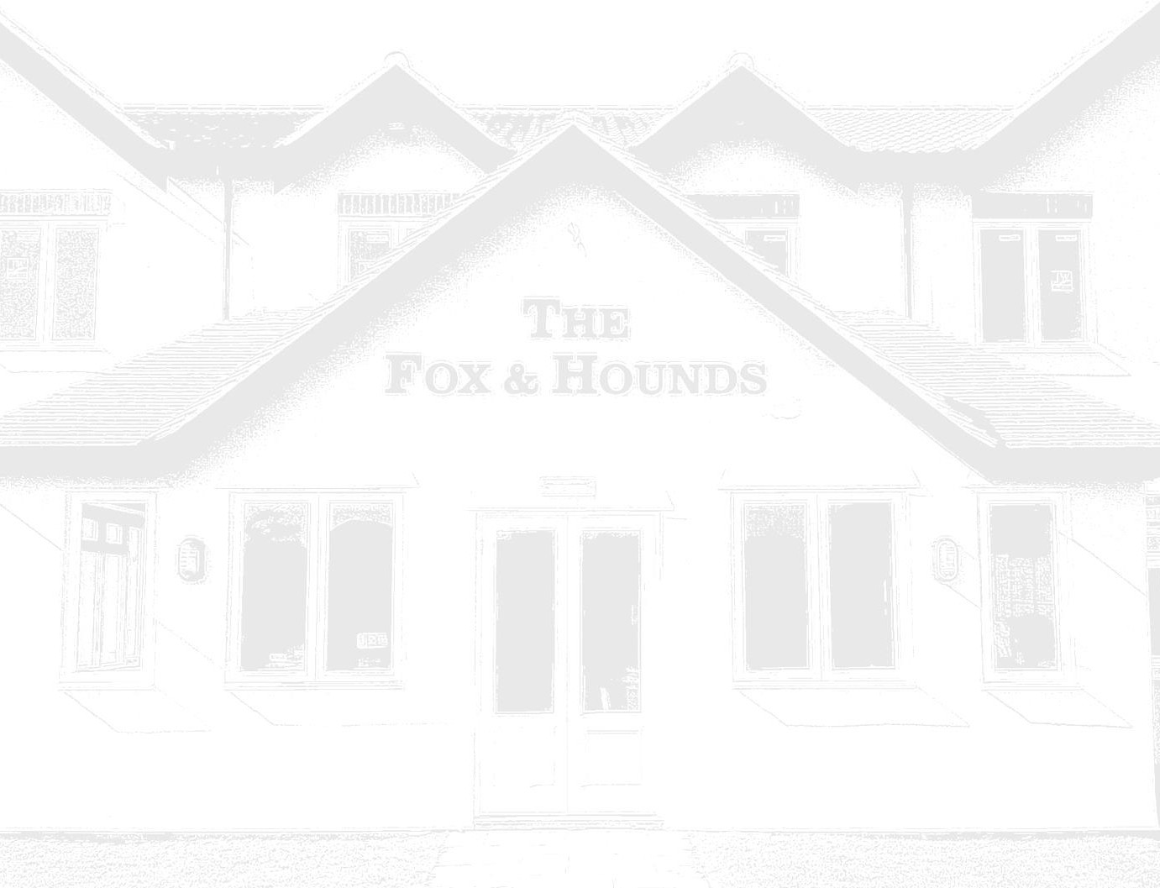

Christmas Day Menu 2026

As it is Christmas Day and there is only one sitting, Service is a more relaxed atmosphere, please allow up to 3 - 4 hours for your visit.
£110 Per Person (£40 Per Child Under 12 Years Old, Please see Children's Menu)

Starters
Cullen Skink – A Hearty Smoked Haddock & Potato Soup – Chive Oil – Croutons – Soft Bloomer
Chicken Liver & Brandy Parfait – Black Pepper Crostini – Pear & Quince Jam – Dressed Leaves
Tempura King Prawn & Mini Crab Balls – Pickled Ginger & Cucumber
Rice Noodle Salad – Crispy Seaweed
Sweet Potato Spinach & Coriander Cake – Lime, Avocado, Pomegranate &
Balsamic Dressing

Intermediate Course
Chorizo Meatballs – Marinara Sauce
Lemon Coriander Falafel – Tzatziki
Ham Hock Croquette – Blue Cheese Sauce

Main Course
Traditional Roast Breast of Turkey – Sausage & Bacon Roll – Stuffing – Roast Potatoes – Turkey
Gravy – Yorkshire Pudding
Slow Roasted Brisket of Beef – Brown Beech Mushroom & Thyme Jus – Dauphinoise Potato – Parsnip Crisp
Chicken Breast Roulade Supreme – Stuffed with Black Pudding & Wrapped in Smoked Bacon – Peppercorn Sauce – Mustard Mashed Potato
Whole Baked Rainbow Trout – Lemon, Dill & Prawn Butter – White Wine Sauce – Baby Roast potatoes
Aubergine Schnitzel – Topped with a Rich Tomato Sauce & Toasted Pinenuts – Feta Cheese Pesto Roasted Baby Potatoes

All served with: Sprouts with Bacon Chestnuts – Honey Roasted Carrots & Roasted Parsnips – Seasonal Greens

Desserts
Traditional Christmas Pudding – Brandy Sauce or Brandy Butter Gluten Free Chocolate Brownie – Toffee Fudge Ice Cream
Black Cherry Bakewell Tart – Double Chocolate Ice Cream
Chocolate & Mint Cheesecake – White Chocolate Ice Cream
Lemon Curd Crème Brulee – Boozy Raspberry Compote & Vanilla Shortbread
Small Cheeseboard – Perl Wen Brie – Silver Fox Cheddar – Shropshire Blue
Grapes – Celery – Apple & Celery
Selection of Ice Creams – Vanilla – Double Chocolate – Toffee Fudge (3 Scoops)

Coffee & Mince Pie

Children’s Menu
Christmas Themed Goodie Bag to Keep the Kids Entertained
Soup or Fruit Juice
Turkey, Sausages or Fish Goujons
Christmas Pudding, Ice Cream or Chocolate Brownie
All Bookings require £55 per person deposit

